**Assignment 1**

**Web page using Html/CSS – webpage portfolio**

|  |  |
| --- | --- |
| Date | 22th September 2022 |
| Student Name | Harsini S.R. |
| Student Roll Number | 111519205011 |
| Maximum Marks | 2 Marks |

**Question:**

1. Create user table with user with email, username, roll number, password.
2. Perform UPDATE, DELETE Queries with user table
3. Connect python code to db2
4. Create flask app with registration page, login page and welcome page.

By default load the registration page once the user enters all the field store the data in the database and navigate to login page authenticate user username and password. If the user is valid show the welcome page.

**Solution:**

**App.py**

from flask import Flask,render_template,request,redirect,url_for

import sqlite3

app = Flask(__name__)

@app.route('/',methods=["GET","POST"])

def index():

if(request.method=="POST"):

rollno = request.form.get("rollno",'')

email = request.form.get("email")

username= request.form.get("username",'')

password= request.form.get("password",'')

with sqlite3.connect("users.db") as con:

cur=con.cursor()

cur.execute("INSERT INTO user (roll_number,email,username,password) VALUES (?,?,?,?)",(rollno,email,username,password))

con.commit()

return redirect(url_for('login'))

return render_template('signup.html')

@app.route('/login',methods=["GET","POST"])

def login():

if(request.method=="POST"):

username= request.form.get("username",'')

password= request.form.get("password",'')

with sqlite3.connect("users.db") as con:

cur=con.cursor()

cur.execute("select * from user where username(?) and password =(?)",(username,password))

result= cur.fetchone()

con.commit()

if result==None:

return render_template("login.html",msg="Invalid username or password, try again!")

else:

return render_template("home.html",username=result[1])

return render_template('login.html')

if __name__ == '__main__':

app.run(debug=True)

**db.py**

import sqlite3

conn = sqlite3.connect('users.db')

print("Opened database successfully")

conn.execute('''CREATE TABLE users (email varchar(100), username varchar(100), roll_number int PRIMARY KEY, password varchar(100));''')

print("Table created successfully")

conn.close()

**registration – signup page:**

**signup.html**

<html>

<head>

<meta charset="UTF-8" />

<meta http-equiv="X-UA-Compatible" content="IE=edge" />

<meta name="viewport" content="width=device-width, initial-scale=1.0" />

<title>Harsini Registration Page</title>

<style>

body {

width: 50%;

margin: auto;

background: #e9e9e9;

color: #939393;

font: 400 87.5%/1.5em "Open Sans", sans-serif;

}

h1 {

color: #000;

font-size: 30;

text-align: center;

padding: 1em 0;

margin: 40;

}

form{

padding: auto;

}

.item{

padding: auto;

text-align: center;

font-size: larger;

color: #000;

min-width: 400px;

}

input[type=submit] {

width: 100%;

padding: 15px 20px;

align-self: center;

align-items: center;

font-size: large;

margin-top: 30;

}

input[type=submit]:hover {

background-color: #74bfcb;

}

input[type=password], [type=email],[type=text] {

width: 70%;

padding: 12px 20px;

display: inline-block;

border: 1px solid #ccc;

border-radius: 4px;

box-sizing: border-box;

font-size: large;

}

label{

text-align: left;

align-self: flex-start;

align-items: flex-start;

}

.overall{

background-color: #ccc;

padding: 30;

}

</style>

</head>

<body>

<div class="overall">

<h1>Registration Form</h1>

<form method="post" action="">

<div class="item">

<label for="email">E-mail</label><br><br>

<input type="email" name="email" required="required" placeholder="Email Address"></input><br><br>

</div>

<div class="item">

<label for="text">User Name</label><br><br>

<input type="text" name="username" required="required" placeholder="User Name"></input><br><br>

</div>

<div class="item">

<label for="text">Roll number</label><br><br>

<input type="text" name="rollno" required="required" placeholder="Roll number"></input><br><br>

</div>

<div class="item">

<label for="password">Password</label><br><br>

<input type="password" name="password" required="required" placeholder="Password"></input><br><br>

</div>

<input type="submit" value="Submit">

<small><u>Login here <a href="{{url_for('login')}}"></a></u></small>

</form>

</div>

</body>

</html>

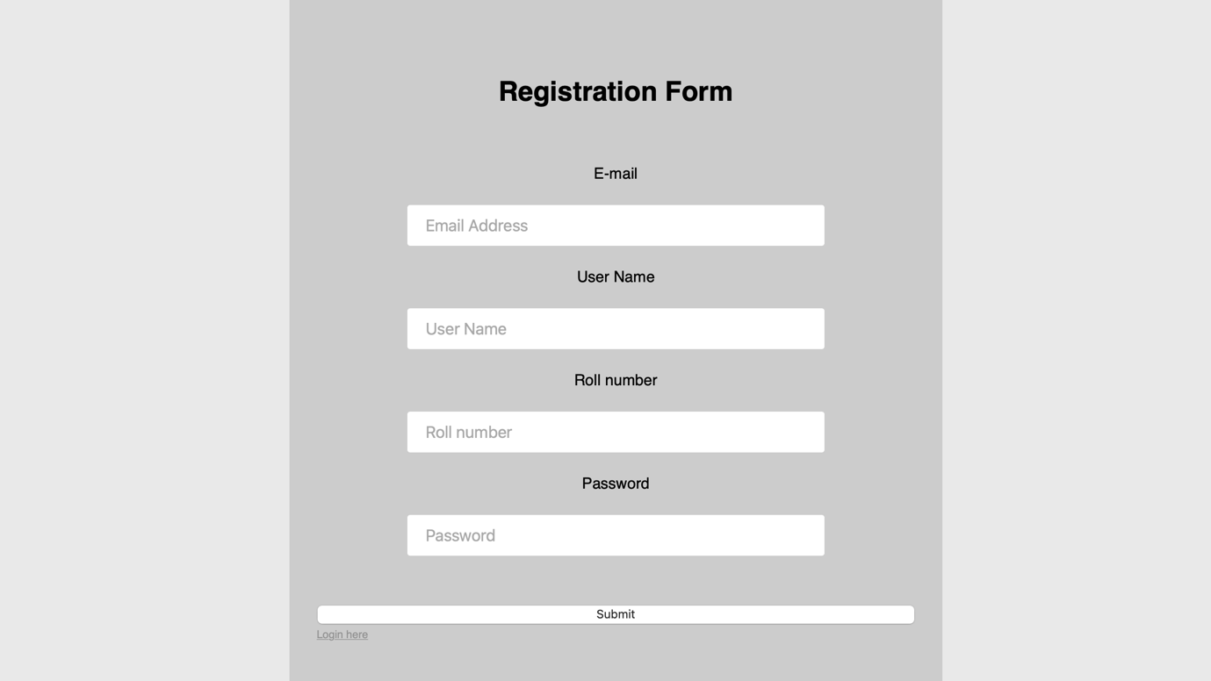

**Login.html**

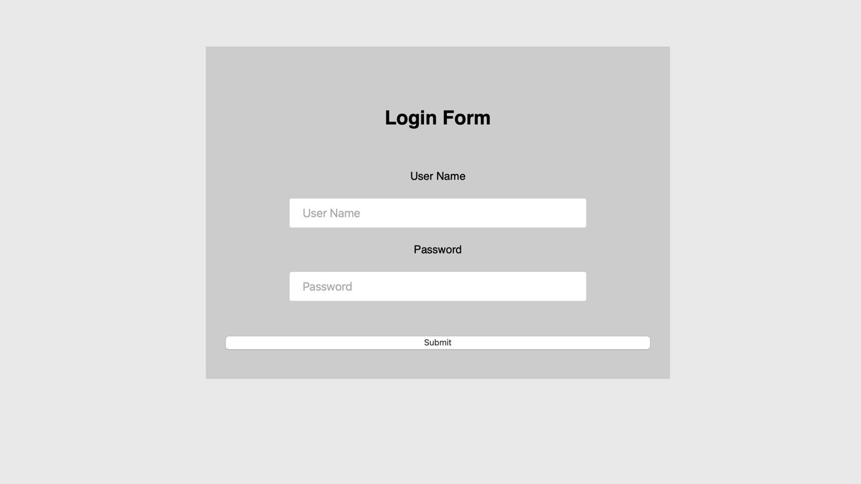

<html>

<head>

<meta charset="UTF-8" />

<meta http-equiv="X-UA-Compatible" content="IE=edge" />

<meta name="viewport" content="width=device-width, initial-scale=1.0" />

<title>Harsini Login Page</title>

<style>

body {

position: absolute;

top: 10%;

left: 25%;

width: 50%;

margin: auto;

background: #e9e9e9;

color: #939393;

font: 400 87.5%/1.5em "Open Sans", sans-serif;

}

h1 {

color: #000;

font-size: 30;

text-align: center;

padding: 1em 0;

margin: 40;

}

form{

padding: auto;

}

.item{

padding: auto;

text-align: center;

font-size: larger;

color: #000;

min-width: 400px;

}

input[type=submit] {

width: 100%;

padding: 10px 20px;

align-self: center;

align-items: center;

font-size: large;

margin-top: 30;

}

input[type=password],[type=text] {

width: 70%;

padding: 12px 20px;

display: inline-block;

border: 1px solid #ccc;

border-radius: 4px;

box-sizing: border-box;

font-size: large;

}

label{

text-align: left;

align-self: flex-start;

align-items: flex-start;

}

.overall{

background-color: #ccc;

padding: 30;

}</style>

</head>

<body>

<div class="overall">

<h1>Login Form</h1>

<form method="POST" action="">

<div class="item">

<label for="text">User Name</label><br><br>

<input type="text" name="username" required="required" placeholder="User Name"></input><br><br>

</div>

<div class="item">

<label for="password">Password</label><br><br>

<input type="password" name="password" required="required" placeholder="Password"></input><br><br>

</div>

<input type="submit" value="Submit">

</form>

</div>

</body>

</html>

**Welcome page – homepage.html**

<html>

<head>

<meta charset="UTF-8" />

<meta http-equiv="X-UA-Compatible" content="IE=edge" />

<meta name="viewport" content="width=device-width, initial-scale=1.0" />

<title>Harsini Welcome Page</title>

<style>

h1 {

color: #000;

font-size: 30;

text-align: center;

padding: 5em 0;

margin: 40;

}

</style>

</head>

<body>

<h1>Hi there! Welcome , you login was successfull!</h1>

</body>

</html>

